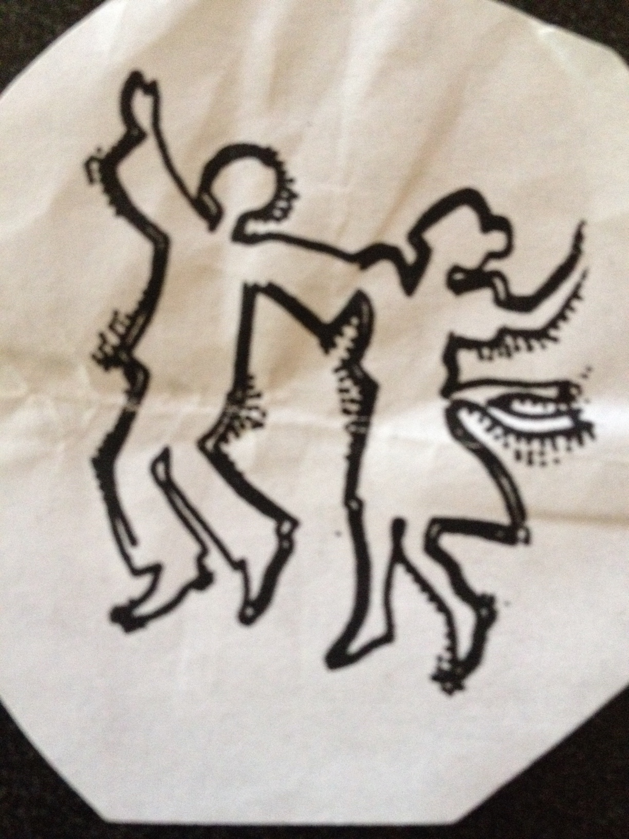

**!!! B’YACHAD PNW ’22 !!!**

Pacific NW’s Open Israeli Folk Dance Weekend Retreat

At the beautiful STAMPFER CENTER / Camp Solomon Schechter,

Olympia, Washington

FRIDAY, AUG. 19 thru SUNDAY, AUG 21, 2022

PNW’s Great Session Leaders lead dance sessions

at this Fabulous Retreat for Intermediate/Advanced Dancers!

FRIDAY after 2pm: Check-In, DANCING, Erev Shabbat dinner, family dancing, and more open DANCING til…

SATURDAY: Shabbat celebration; all meals and snacks; DANCING; rest and fun at camp*;

afternoon PARTNER DANCING, Yoga, kids dancing; Havdalah and more DANCING ‘til...

SUNDAY: Brunch; check out by noon.

*Registered Dancers/Family/Friends enjoy camp amenities: swimming, paddle boats and canoes on private Lake Stampfer, basketball, tennis, hiking, etc.

—— R E G I S T R A T I O N LIMITED TO 60 DANCERS———

COVID vac. and booster required to attend the facility (unless documented medical reason)

Non-dancing Family and Friends MOST WELCOME!

Registration Includes all kosher meals and snacks, camp cabin-style lodging (no more than 4 to a cabin),

music CD or flash drive and all activities. Cabins are heated with bunks, bathrooms and showers, windows for

ventilation – please bring bedding and towels. More private accommodations for couples/families

Dancer’s Registration, US Currency, Non-Dancer Family-Friends** Registration, US Currency

$310.00 per person $275.00 per person

$105 per child ages 5-12; $175 per child ages 13-17; under age 5, free

**\*\***Non-dancing registered guests welcome and “on their own” to enjoy camp facilities while we’re dancing:

Children welcome and MUST Be Supervised by Parents At All Times

Confirmation and all other details to be sent to you by email after registration received.

No Drop-Ins, No Smoking, No non-vaccinated/boosted registrants, No Pets Please

Located at The Stampfer Center/Camp Solomon Schechter and sponsored by PNW Israeli dance leaders

Questions? Please contact Deb Montrose, B’YACHAD PNW Administrator at 503-544-2641, or [debbirm@aol.com](mailto:debbirm@aol.com)

— Clip and mail - - - - - - - - - - - - - - - - - - - - - - - - - - - - - - - - - - - - - - - - - - - - - - - - - - - - - - - - - - - - - - - - - - - - - - - - - - - - - - - - - - - - - - - - - - - - - - - -

Please register me/us for B’YACHAD ’22 Israeli Dance Weekend at THE STAMPFER CENTER Aug. 19-21, 2022

DANCER(S)’ INFORMATION________________________________________________________________ _________________________

Name(s) phone

_______________________________________________________________________________________ ___________________________

address zip email

Non-Dancer(s) ________________________________________________________________ ___________________________________

Family members/friends, ages of children

Room mate choice(s)? (no more than 4 to a bunk this year)_________________________________________________________________

Payment Options: ____Personal Check payable to Deb Montrose/B’YACHAD ’22, or VENMO to Debra Montrose: $___________

____VISA or, ____ MC #______________________________________________________ $_____________

exp. Date ___________________________

Optional donation to help a dancer in financial need to attend, thank you! $__________

Please include payment with your registration and mail to TOTAL = $__________ Deb Montrose, 13985 NW Harvest Lane, Portland, OR 97229

Debbi Montrose, B’YACHAD PNW Administrator, 13985 NW Harvest Lane, Portland, Oregon 97229 USA LOOKING SO FORWARD TO DANCING TOGETHER AGAIN!

SEE YOU AT B’YACHAD ’19!!!!